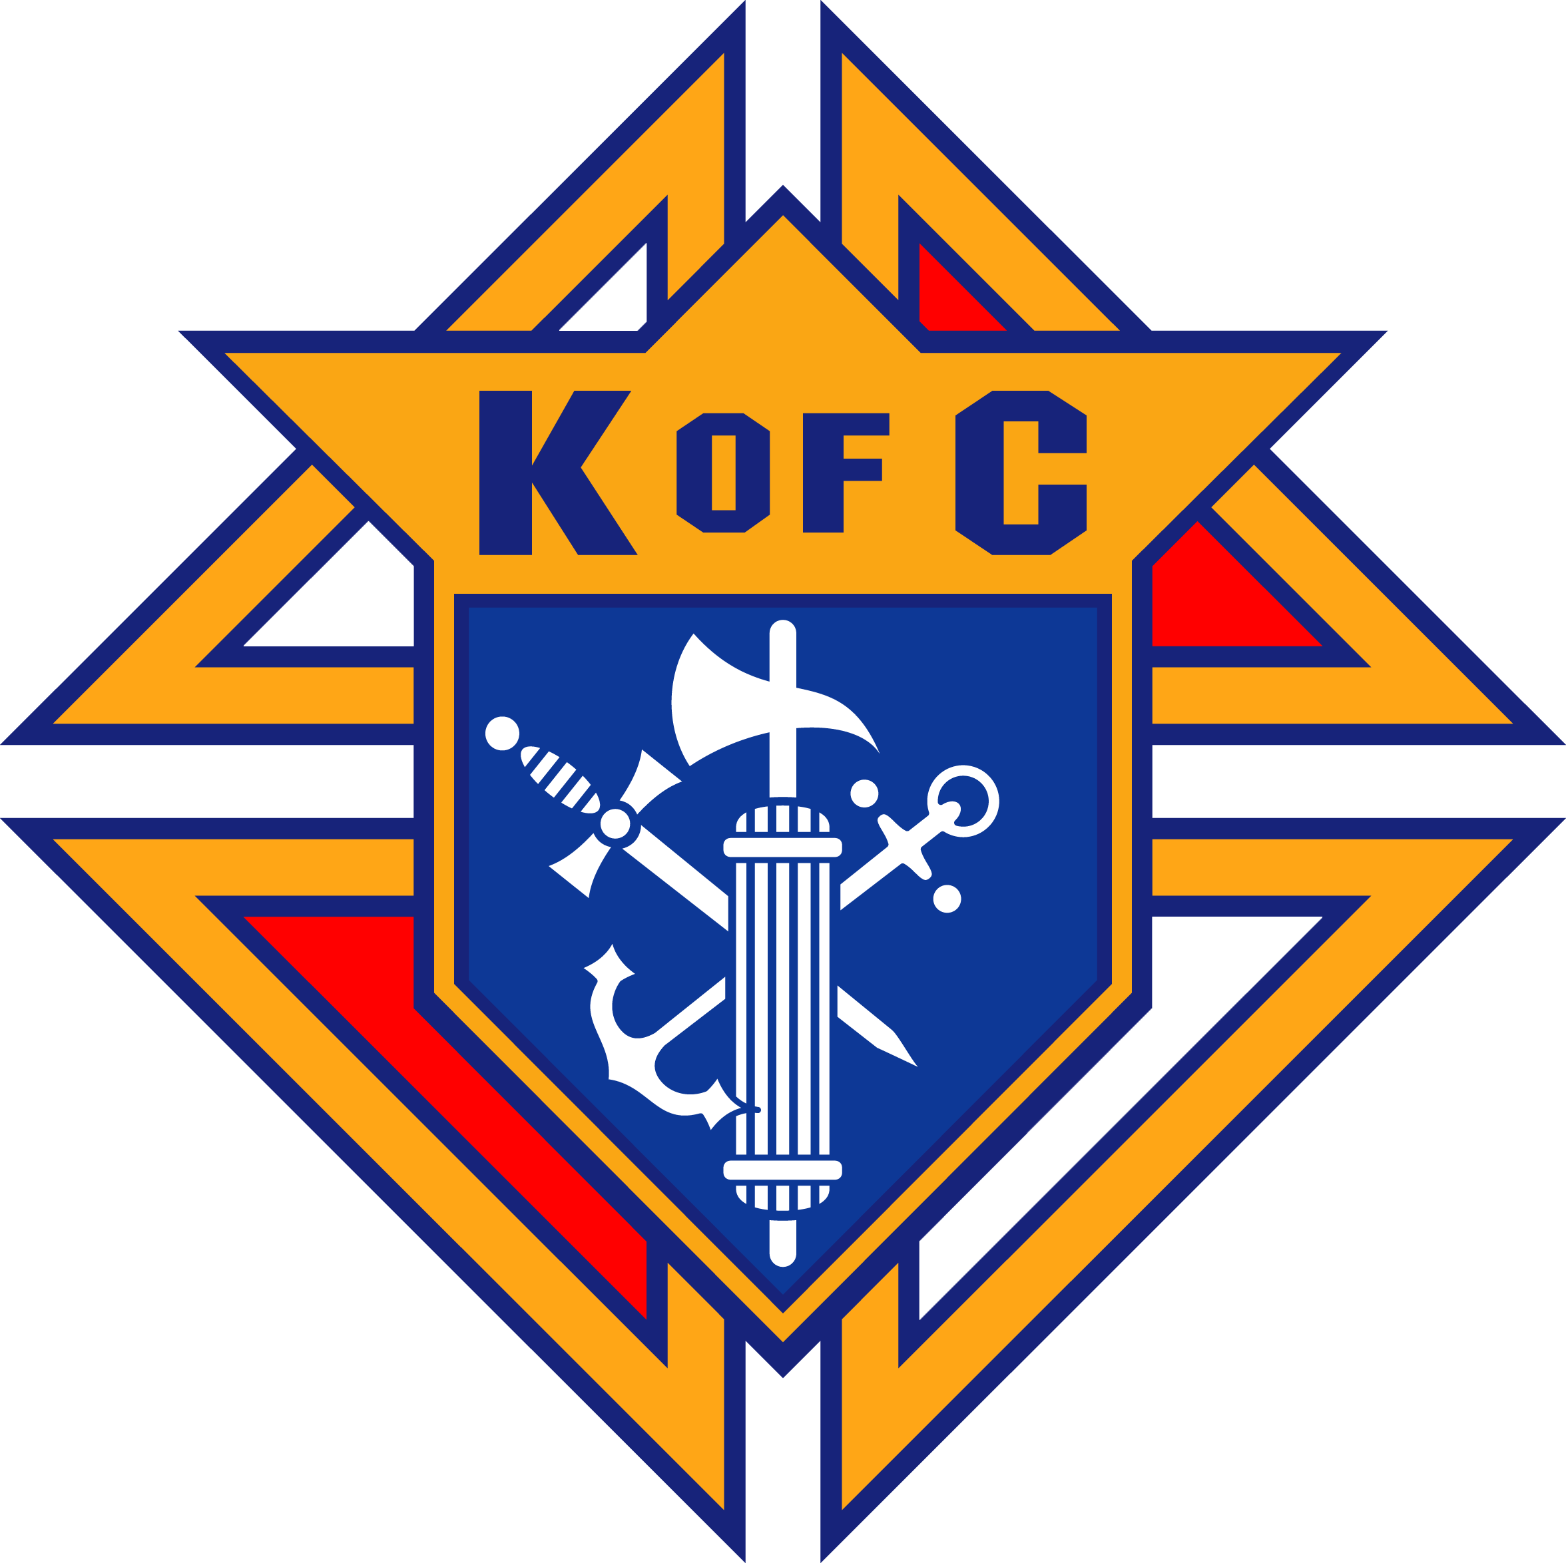 ***Knights of Columbus*** West Virginia State Council

Scholarship Foundation

Eligibility Rules & Information for

Knights of Columbus Wheeling University Scholarship

1. To be eligible for a Knight of Columbus Wheeling Jesuit University Scholarship, you must

submit the following documents.

a) A letter from the University that you are enrolled or have been accepted for

admission.

b) A letter from the KofC Council of which you or your father is a member in good

standing.

c) A transcript of your grade point average (GPA) including first semester Senior year

d) A complete Knights of Columbus Wheeling University Scholarship form.

e) An autobiographical statement, which includes the following topics:

1. Church Activities.

2. School & Community Activities.

3. Goals & Objects.

2. The above documents can be submitted to the University Financial Aid Office or directly to the

West Virginia Knights of Columbus Scholarship Foundation, Inc. at:

WV K of C Scholarship Foundation, Inc.

Attn: Anthony J. Paletta

2687 Benedum Dr,

Bridgeport, WV 26330-7199

If you have any questions or need additional information, please contact me at:

(304)627-0814 or E-mail [anthonypaletta71@gmail.com](mailto:anthonypaletta71@gmail.com) .

The deadline for submitting the application packet is **April 20, 2022.**

If you wish to apply for the State Council’s other KofC Scholarship a separate and complete packet must be submitted on that scholarship form. For both scholarships only completed packets will be accepted.