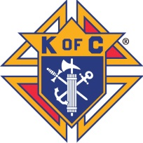
KNIGHTS OF COLUMBUS
WEST VIRGINIA STATE COUNCIL

NECROLOGY REPORTING SHEET

DATE: 2/26/2026

Name: Click here to enter name of deceased. Date of Death.: Click here to enter date
Council #: Enter number. Council Name: Enter council name.
Office Held: (check all that apply) ☐Grand Knight ☐Financial Secretary ☐Chaplain
Assembly #: Enter number. Assembly Name: Enter assembly name.
Office Held: (check all that apply) ☐Faithful Navigator ☐Faithful Comptroller ☐Friar
Former District Deputy? ☐Yes ☐No If yes, District # Enter number.
Past State Deputy? ☐Yes ☐No
Past State Officer? ☐Yes ☐No If yes, highest office held: Enter highest office.
Former District Master? ☐Yes ☐No
Former Vice Supreme Master? ☐Yes ☐No

Please return to:
Thomas Burke
WV Knights of Columbus
State Secretary
46 Redwood Lane
Wheeling, WV 26003
Or tburke1038@aol.com

